# Part A

## Task 2: RESTful Web Service

The student has used the existing RESTful web service, and the mobile application has the following capabilities:

First, RESTful web services are available and hosted via Oracle cloud VPS with Django REST framework as backend. This can be accessible via <http://192.9.174.169/api/>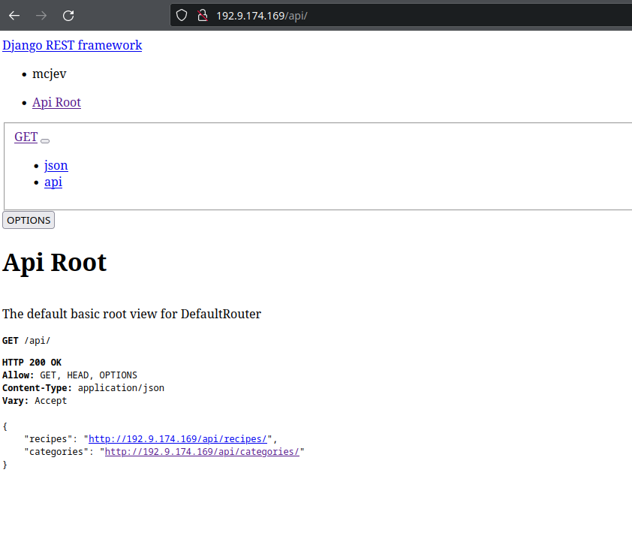

• Call a REST service using HTTP.



• Retrieve datafrom the web service.



• Parse the response and extract the relevant information.



This line is using the json() method of the Response object returned by the fetch() function to extract the response body as a JSON object. The JSON object contains an array of category objects, each with an id, title, and image property. The setCategories(data) function then updates the categories state with this extracted data.

• Displays the information in a user-friendly way, with appropriate use of UI components and design.

Below are the data from RESTapi backend that has been parsed on the front end and displayed on screen.

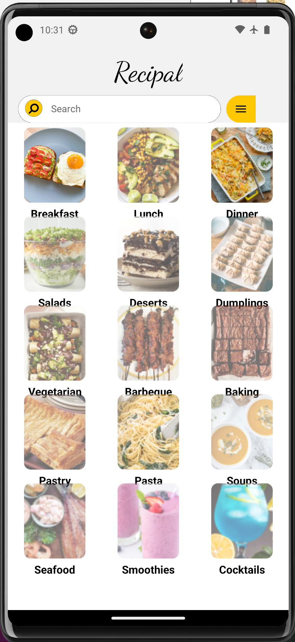

# Part B

## Task 1:

Online Data Integration Storage

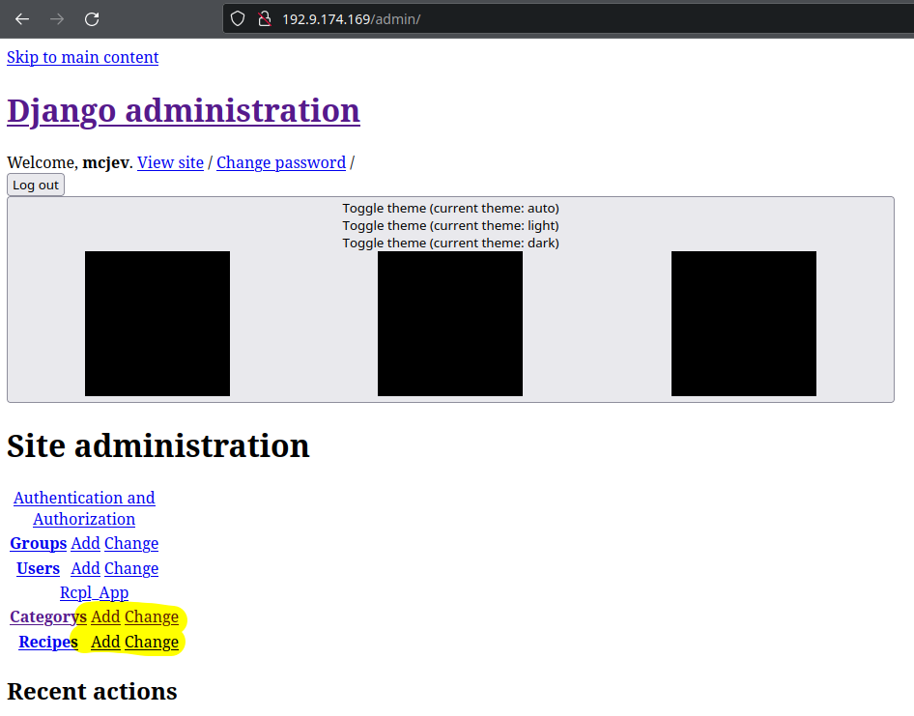

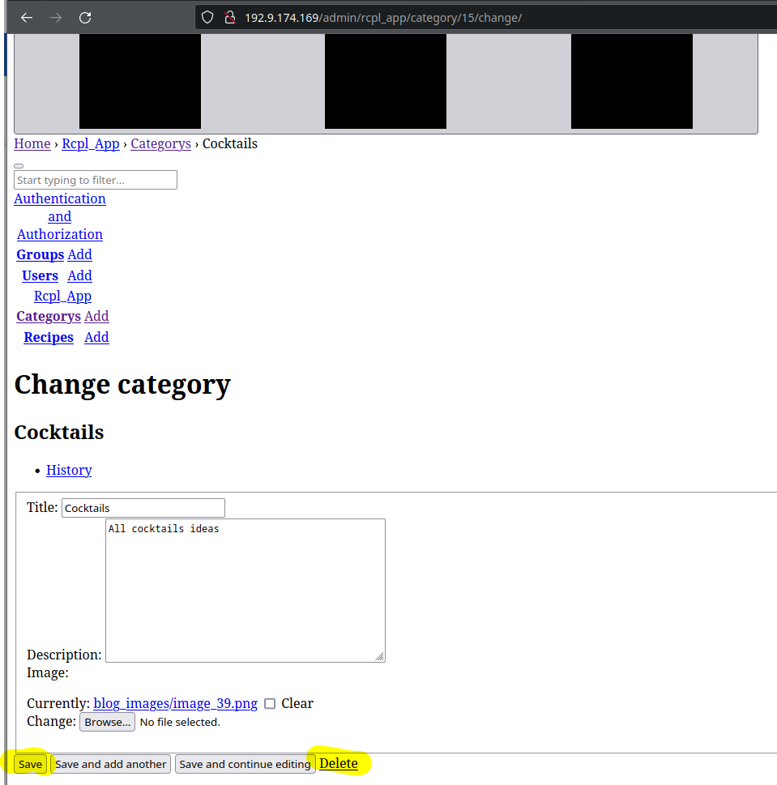

Offline data Integration storage

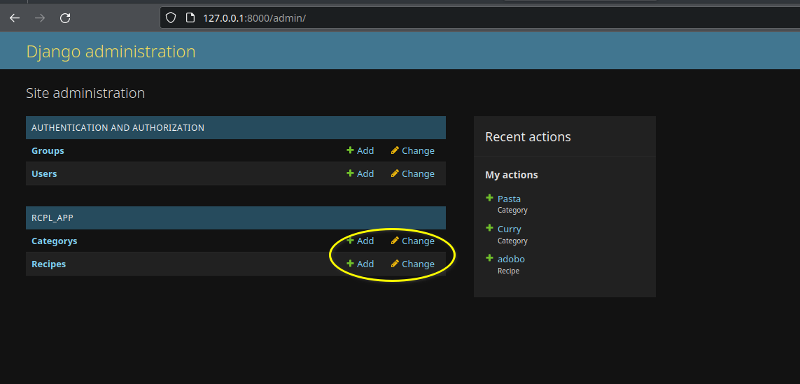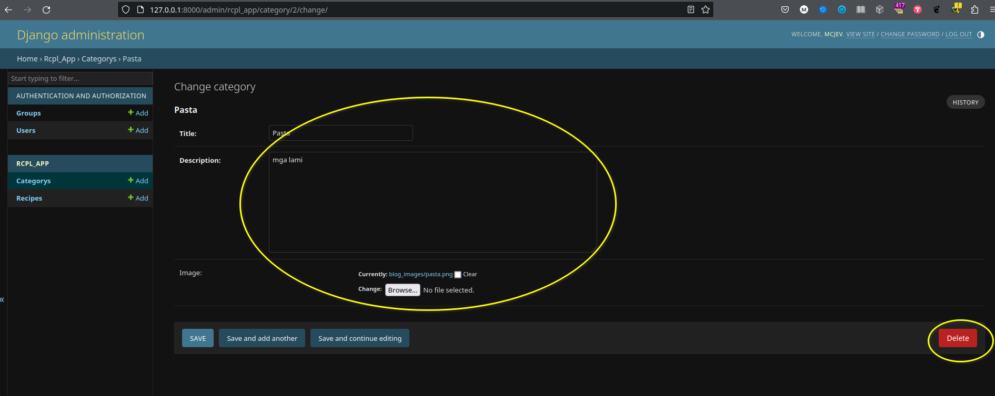

# Part C

## Task 1

